
Missing Data Mechanism: Completely at random
MCAR (Acaso) at random MAR (Observável, a
variável), algo que está no nosso conjunto de
dados) at random (not) MNAR (OBS/ Not OBS)
pode depender de algo que observamos, mas pode depender de algo que não observamos
Evento| Variável de interesse, key value

2 variáveis aleatórias, R e Y, qual a probabilidade
de omissão, dado Y
Mitigar o problema maior (MNAR), então adicionamos variáveis auxiliares, um seguro contra MNAR
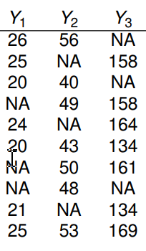
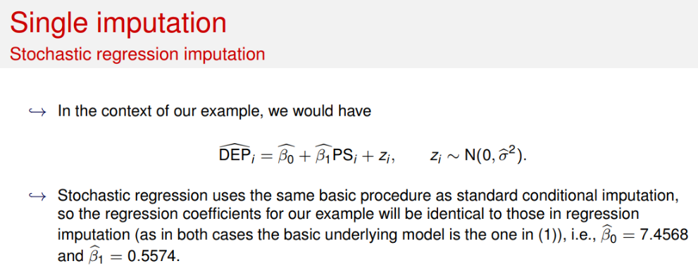
Qualquer função do R lida de forma própria com os valores omissos. Require e o nome do pacote! (na censura há informação partial), é um dos procedimentos típicos, complete case análise remove uma linha assim que que aparece um NA.
Para o CCA, temos 2 linhas completas 6 e 10. Y-1=22.5 Y-2=48. Para ACA pensamos por colunas para a média e variãncias.

Covariância entre, média e matriz de covariância! | Imputação como uma previsão!
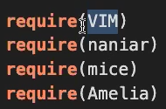
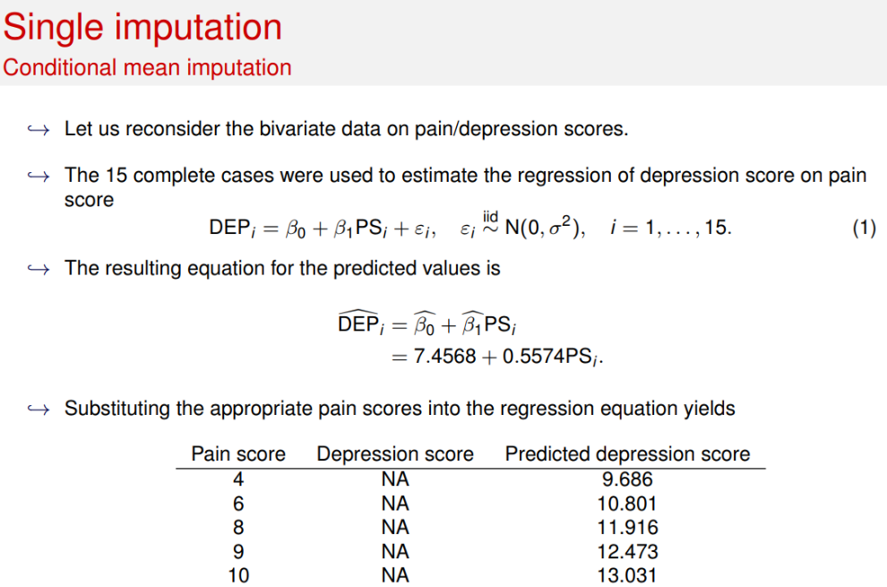
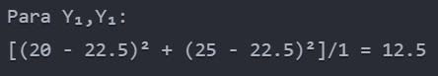
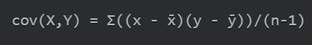
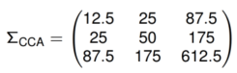
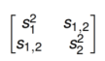
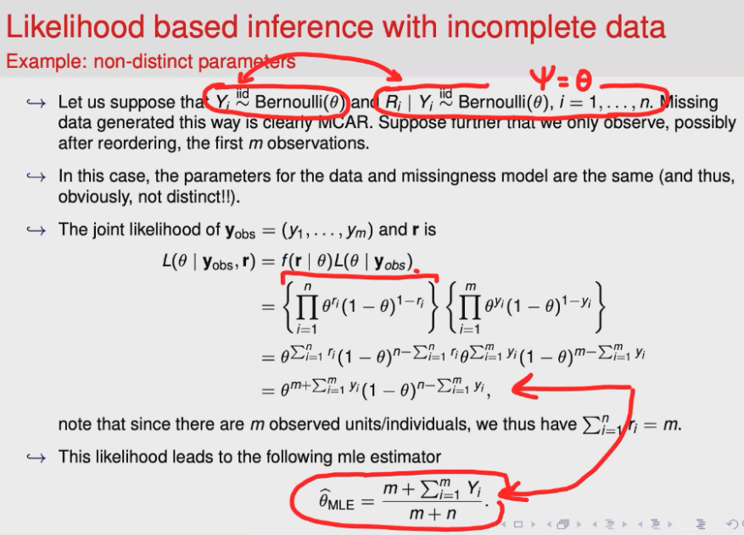

S= (-2.5*-5+2.5*5)(2-1)=25= =25=
MNAR. Data on income are missing because people with higher incomes are less likely to reveal them, thus MNAR. (b) MCAR. Missing observations are due to contamination and not related to the missing data themselves or any other factor, and thus missing data are MCAR. (c) MAR. Employment status of some Hispanic individuals is missing. Because race is a fully recorded variable, the missing data are MAR. 2. The largest possible subsample under a complete case analysis is 475, corresponding to the case where the missing values occur in all the 10 variables exactly for the same subjects. The smallest possible subsample under a complete case analysis is 0, corresponding to the extreme case where missing values occur for ‘non overlapping sets of subjects’ (e.g., for the first variable, individuals 1–25 have missing values, for the second variable, individuals 26–50 have missing values, . . . , for the 20th variable, individuals 475–500 have missing values). 3. (a) First, note that although not required, the induced distribution on (Y1, Y 2) is a bivariate normal distribution with means (1, 5), variances (1, 5), and correlation 2 Ô5 = 0.89. The missingness mechanism is MAR. Missingness on Y2 depends on Y1, which is fully observed, and on Z3 which is not in our dataset but is uncorrelated to Y2 (by construction). I have fixed the seed (to 1) and simulated the data as follows.

